UNIT V – PHASE RULE
PART – A
1. Give the merits and limitations of Phase rule. (Jan 11, 13)

Phase rule - Merits
- applicable to both physical and chemical equilibria.
- different systems with same degree of freedom behave similarly.
Limitations
- applied only for single and heterogeneous equilibrium systems.
- electric and magnetic influence have not been considered.

2. What is condensed phase rule or reduced phase rule? (Jan 14, 15, May 13, 14, 19)
Condensed or reduced phase rule
In solid-liquid equilibrium of alloy, no gas phase is considered and effect of pressure is small. Therefore, experiments are conducted under atmospheric pressure.
Thus, keeping pressure constant, in which vapour phase is not considered, is called condensed system. Since degree of freedom of system is reduced by one, phase rule becomes, F = C – P + 1

3. Differentiate Triple point, Melting point and Eutectic point. (May 13, 15)
Melting point | Eutectic point | Triple point
Solid A Liquid A | Solid A + Solid B Liquid | Solid Liquid Vapour

4. Explain triple point and its significance? (Jan 13)
Triple point - Significance
- At triple point, three phases are in equilibrium. Solid Liquid Vapour
- As P = 3, F = 3 – P = 3 – 3 = 0. Since three phases co-exists, system is invariant or non-variant.
Example : In water system, at triple point the temperature is 0.0098°C and pressure is 4.58 mm.

5. Write note on eutectic system with its application.
Eutectic system
A binary system consisting of two substances, which are miscible in all proportions in liquid phase, which do not react chemically. (easy to melt).
Example : Mixture of lead and silver.
Applications: Low-melting alloys used in safety devices as plugs in automobiles and fire-sprinklers.

6. Explain Eutectic mixture and Eutectic point. (Jan 13, 14, 15, May 13)
Eutectic mixture: It is a solid solution of two or more substances having lowest freezing point of all possible mixture of components.
Eutectic point: Minimum freezing point attainable corresponding to eutectic mixture.
Example : Lead–Silver system: Eutectic point = 303 ºC, Eutectic mixture, Ag = 2.6% and Pb = 97.4%.

7. Explain solidus and liquidus solution. (May 13)
Solidus and liquidus solution
When two metals completely miscible in both solid and liquid states, they form solid solutions. Two smooth curves forming a loop characterize solid solution.
Upper curve is liquidus curve, above which only liquid is present and lower curve is solidus curve below which only solid phase is present.
Example : Cu - Ni system.
PART – B
1. State Phase rule and explain the terms with example. (Jan 13, 14, 15, May 11, 12, 13, 14, 15)

Phase Rule
- if equilibrium of phases is not affected by external factors like gravity, or electrical, or magnetic forces
- if affected only by temperature, pressure and concentration
- then number of degrees of freedom (F) is related to number of components (C) and number of phases (P) by phase rule equation,
F = C – P + 2

Terms in Phase rule are (a) Phase (b) Component (c) Degree of Freedom

(a) Phase
Phase is a homogeneous, physically distinct and mechanically separable part of a system.
It is separated from other parts of system by definite boundary surfaces.
Example
Gaseous mixture (N₂ and H₂) miscible in all proportions, gives one phase.

(b) Component
It is minimum number of independent species necessary to state composition of all phases present in the system in the form of chemical equation.
Example
Water exists in ice, water and vapour, but chemical composition is H₂O. Hence it is one component.

(c) Degree of Freedom
- It is minimum number of independent variables like temperature, pressure and composition
- which must be specified in order to represent condition of system completely.
Example
In gaseous mixture of N₂ and H₂, both pressure and temperature are needed, hence two degrees of freedom.

2. Explain Water system. (Jan 11, 15, May 14, 15, 19)
Water system
Water system consists of three phases, Ice, Water and Water Vapour. All phases represented by one chemical species H₂O, it is one component system. Phase rule equation is F = C – P + 2
When C = 1, phase rule equation becomes, F = C – P + 2 = 1 – P + 2 = 3 – P
(i) 3 single phases exist separately: Ice (s), Water (l) and Vapour (g)
(ii) 3 two phase equilibrium: Ice Water, Water Vapour, Ice Vapour
(iii) 1 three phase equilibrium: Ice (s) Water (l) Vapour (g)
Three possible cases are,
- P = 1; F = 2 (bivariant system)
- P = 2 ; F = 1 (univariant system)
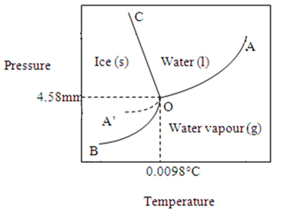
- P = 3 ; F = 0 (invariant system)
Phase diagram

Phase diagram for water system consists of,
(a) Areas (b) Curves (c) Triple Point (d) Metastable Curve
(a) Areas
Each area represents single phase, BOC (solid ice), AOC (liquid water) and AOB (water vapour).
F = 3 – P = 3 – 1 = 2 (bivariant)
Within these areas, both temperature and pressure needed to explain system.
(b) Boundary lines or Curves
Areas are separated by boundary lines or curves at which, two phases co-exist in equilibrium.
F = 3 – P = 3 – 2 = 1 (univariant), either temperature or pressure should be known.
- Curve OC: melting curve (Ice water), inclined towards pressure.
- Curve OA: vapourization curve (water water vapour), has upper limit +374°C and 218 atm.
- Curve OB: sublimation curve (ice water vapour), has lower limit – 273°C.
(c) Triple Point
Point O, at which all three phases exists in equilibrium, is called Triple Point.
F = 3 – P = 3 – 3 = 0 (invariant or non-variant)
There is no degree of freedom or three phases can coexist in equilibrium only at definite temperature of
0.0098°C and pressure of 4.58 mm.
(d) Metastable curve
When water is cooled in clean vessel, it remains liquid below its freezing point without formation of ice. It is called super-cooled water and curve OA’ is unstable and called as Metastable curve.

3. Discuss Sulphur system. (Jan 13, 14, May 11, 12)
Sulphur system
Sulphur exists in two enentiotropic forms, Rhombic (S_{R}) and Monoclinic (S_{M}) sulphur and there are liquid sulphur (S_{l}) and vapour sulphur (S_{v}), totally four phases.
All phases are denoted by S, it is one component system, phase rule equation is F = C – P + 2
Out of four phases only three can co-exist at a time. Possible equilibriums are,
- P = 3, F = 0 (invariant)
- P = 2, F = 1 (univariant)
- P = 1, F = 2 (bivariant)
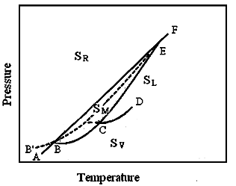
Phase diagram

Sulphur phase diagram consists of
- Areas (b) Curves (c) Triple Points (d) Metastable curves
(a) Areas
Sulphur has four areas of single phase, ABEF - sulphur Rhombic (S_{R}), DCEF - sulphur liquid (S_{L}), ABCD - sulphur vapur (S_{v}) and BCE - sulphur Monoclinic (S_{M}).
F = 3 – P = 3 – 1 = 2 (bivariant), both temperature and pressure are needed.
(b) Curves
There are six lines representing equilibria of two phases.
F = 3 – P = 3 – 2 = 1 (univariant), pressure or temperature is needed.
- Curve AB: (S_{R} S_{v})
(ii) Curve BC: (S_{M} S_{v})
(iii) Curve CD: (S_{l} S_{v})
(iv) Curve BE: (S_{R} S_{M})
(v) Curve CE: (S_{M} S_{l})
(vi) Curve EF: (S_{R} S_{l})
(c) Triple points
There are three stable triple points in which three phases are in equilibrium.
F = 3 – P = 3 – 3 = 0 (invariant), changes in T or P, causes disappearance of one of three phases.
- Triple point B: (95.6°C, 0.006 mm) (S_{R} S_{M} Sv )
- Triple point C: (120°C, 0.04 mm) (S_{M} S_{L} S_{V} )
- Triple point E: (151°C, 1290 mm) (S_{R} S_{M} S_{l} )
(d) Metastable equilibriums
(i) Metastable curves: Four curves BG, CG, EG and BB’ indicate metastable equilibria of two phases.
(ii) Metastable Triple point: Point G (114°C, 0.03 mm) is metastable equilibrium of S_{R}, S_{l} and S_{V}.
4. Explain Thermal Analysis. (Jan 11, 13, 14, 15, May 11, 13, 14, 15, 19)
Cooling Curve
A pure substance in liquid state is allowed to cool slowly and temperature is noted at definite times. Graphic representation of rate of cooling will be continuous curve called as cooling curve.
Thermal Analysis
Construction of phase diagram from cooling curves is called Thermal Analysis.
It involves study of cooling curves for pure metals and for various compositions of two components of a system during solidification.
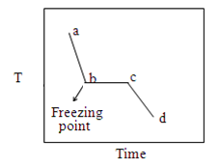
One component
Pure substance in liquid state is cooled slowly and temperature is noted at definite times.
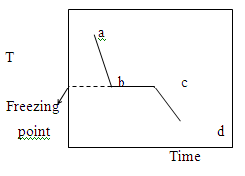
As solid appears, freezing point is reached, shown by break.
At this point temperature remains constant, until liquid is completely solidified.
Thereafter, fall in temperature will again become continuous due to heat dissipation.
Two components
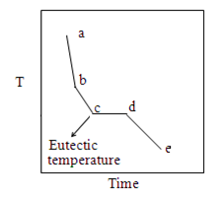
Mixture of two solids in fused state is allowed to cool.
When a solid phase begins, cooling curve exhibits a break. But temperature does not remain constant, it decreases continuously.
When mixture forms eutectic, fall of temperature continues till eutectic point is reached. Temperature remains constant, until solidification is complete.
Then fall of temperature is uniform.

Phase diagram for two component
Pure metals A and B and number of mixtures of various compositions are prepared. These are heated above their respective melting point to give homogeneous liquid.
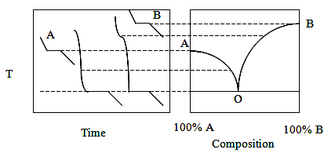
Each liquid is then allowed to cool slowly and temperature is recorded after small interval of time.

Pure metal will freeze at one constant temperature. Freezing point of pure A and B are determined.
For any mixture, it is possible to obtain its freezing point and eutectic point. As mixtures differ in their compositions, their freezing will commence at different temperatures.
Now cooling curve of alloy of same metals, but of unknown composition is determined and its freezing point located in T–C diagram. Composition of this freezing point yields composition of that alloy.

5. Explain Lead – Silver system forming eutectic alloy. (Jan 11, 14, 15, May 11, 13, 14, 15)
Eutectic system
When metals are completely miscible in liquid state and do not give rise to any compound formation are known as simple eutectic system.
Example: Lead – Silver system
Lead – Silver system
This is two–component system with solid Ag, solid Pb, solution of Ag and Pb and vapour.
Gas phase is not considered, hence pressure is neglected. Hence condensed phase rule is applicable.
F = C – P + 1
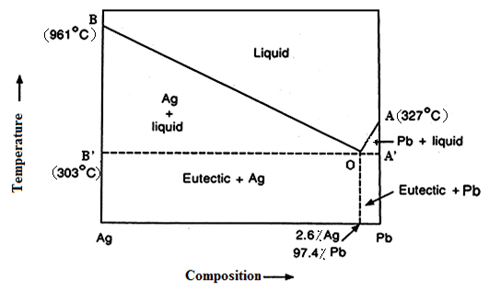
Phase diagram

Phase diagram for Pb – Ag system consists of (a) Areas (b) Curves (c) Eutectic point
(a) Areas
- Area AOB represents solution of Pb and Ag.
- Area AOA’ represents mixture of liquid with solid lead.
- Area BOB’ represents mixture of liquid with solid silver. F = 3 – P = 3 – 2 = 1 (univariant).
(b) Curves
- Curve AO: freezing curve of Lead (Pb liquid)
Pure lead melts at 327°C and addition of silver lower its melting point along AO.
- Curve BO: freezing curve of Silver (Ag liquid)
Pure silver melts at 961°C and addition of lead lowers its melting point along BO.
F = 3 – P = 3 – 2 = 1 (univariant).
(c) (Eutectic Point)
Point O is eutectic point where three phases, solid Pb, solid Ag and their liquid solution coexist. F = 3 – P = 3 – 3 = 0 (invariant)
Eutectic point O (303°C) has fixed composition of Ag = 2.6% and Pb = 97.4%, called eutectic composition.
No mixture of lead and silver has a melting point lower than eutectic temperature. At this point, temperature remains constant, until whole of the melt solidified.
Application - Pattinson’s process
Original argentiferous lead which contained 0.1% (or less) of silver, by phase rule application increased upto 2.6% of silver.

6. Explain the Zn-Mg alloy system. (Jan 13, May 12, 15)
Congruent system
A compound, which melts sharply at constant temperature into a liquid of same composition as solid.
The components form one or more compounds in some stoichiometric proportions.
Example: Zn – Mg system
Zn-Mg alloy system
Zinc and Magnesium melts at 420°C and 650°C respectively. They form a compound MgZn₂, in which the ratio of Mg and Zn in molecular proportions is 1:2. This compound melts at B (590°C).
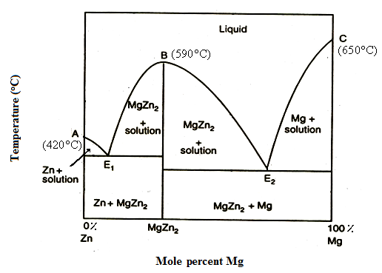
Phase diagram

This phase diagram may be considered as equivalent to two-phase diagrams of Pb–Ag system type placed side-by-side.
One on left consists of Zn and MgZn₂ system; while other on right is formed by MgZn₂ and Mg.
Curves
Curve AE₁ and CE₂ represent composition of liquids in equilibrium with solid Zn and solid Mg.
Eutectic points
There are two eutectic points, E₁ and E₂ where three phases co-exit which is invariant.
Molar composition at E₁ is 79% Zn and 21% MgZn₂ and T is 380°C.
Molar composition at E₂ is 61% MgZn₂ and 39% Mg and T is 347°C.
Compound MgZn₂
Central portion of curve E₁BE₂ has maxima at B (590°C), represents melting point of compound MgZn₂. At maxima B, MgZn₂ can co-exist as solid and liquid of same composition, it is said to possess congruent melting point.
Composition corresponding to maxima is 33.3% Mg and 66.7% Zn. i.e., in the ratio of 1:2.
Sharp maxima indicate that the compound does not dissociate appreciably; whereas a flat maxima indicates as appreciable dissociation, as in the present case.

7. Discuss Copper - Nickel system and mention its application. (Jan 14, May 13, 19, Nov 11)
Solid solution
A homogeneous solid solution constitutes a single phase and there is only one liquid phase.
Maximum number of phases can be 2, and according to phase rule, F = C – P + 1 = 2 – 2 + 1= 1, minimum number of degrees of freedom is one. Thus, the system can never be invariant.
Example: Copper - Nickel system
Copper - Nickel system
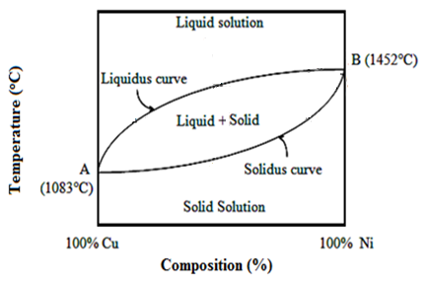
It shows complete miscibility of materials in solid phase. There are two one-phase areas and one two-phase area. This type results from the ability of one substance to substitute freely for others in crystal lattice because of similarity in size of molecules.
Phase diagram

Copper and Nickel are soluble in each other in all proportions in solid state. Freezing points of Cu is 1083°C and Ni is 1452°C.
Addition of Ni to Cu raises freezing point, addition of copper to nickel depresses freezing point.
Solidus and Liquidus curve
Upper curve represents Liquidus or freezing curve, since above this, system is liquid only.
Lower curve represents Solidus or melting curve, since below it, only solid phase exists.
In between solidus and liquidus, both solid and liquid phases co-exist.
Two components form continuous series of solutions, without any minimum or maximum point.
Tie line
Composition of a liquid solution in equilibrium with solid solution is given by a tie line.
This state of affair happens all along curve between melting points of Cu and Ni.
Effect of cooling
Mixture of Cu and Ni in liquid state has two degrees of freedom. F = C – P + 1 = 2–1+1 = 2
Solid appears when reached on line AB. This has solid and liquid phases, F = 2 – 2 + 1 = 1 (univariant)
Presence of Cu diminishes freezing point, the liquid if cooled, freeze at a still lower temperature.
Thus, residual liquid becomes richer in Cu and poorer in Ni.
Application - Fractional crystallization
Mixture of Cu and Ni is heated and cooled repeatedly. By separating solid, pure Ni can be obtained.
Thus pure substances of Cu and Ni can be separated by this fractional crystallization process.
Component which tends to depress freezing point of mixture occurs in greater amounts in liquid state.

